COMSATS Institute of Information Technology

Introduction to Psychology

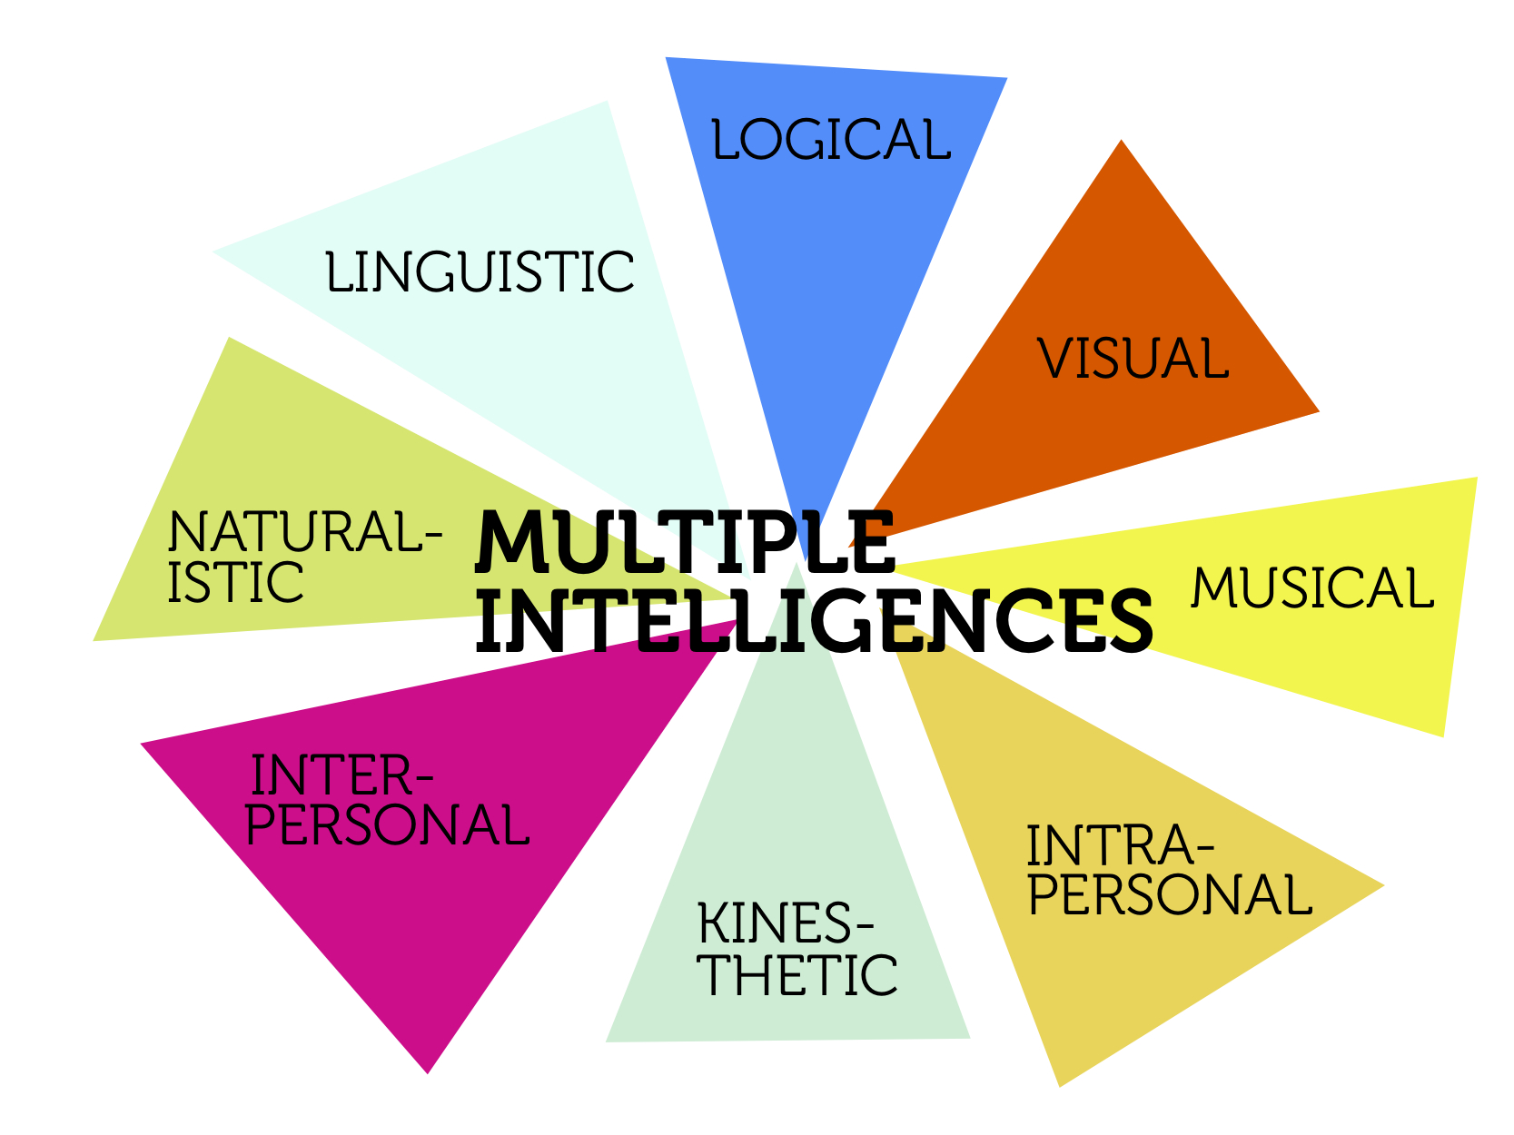

Submitted By:
Ibraheem Faiq, FA10-BCS-239

Submitted to:
Ma’am Shazia Gulzar, Course Instructor

Dated:
12/8/2014

Theory of Multiple Intelligences:
The theory of multiple intelligences is a theory of intelligence that differentiates it into specific (primarily sensory) "modalities", rather than seeing intelligence as dominated by a single general ability. This model was proposed by Howard Gardner in his 1983 book Frames of Mind: The Theory of Multiple Intelligences.
Gardner articulated seven criteria for a behavior to be considered an intelligence.

- Place in evolutionary history.
- Presence of core operations.
- Susceptibility to encoding (symbolic expression).
- A distinct developmental progression.
- The existence of savants.
- Prodigies and other exceptional people.
- Support from experimental psychology and psychometric findings.

Gardner chose eight abilities that he held to meet these criteria.

- Visual-Spatial Intelligence

People who are strong in visual-spatial intelligence are good a visualizing things. These individuals are often good with directions as well as maps, charts, videos and pictures.

Characteristics of Visual-Spatial Intelligence

- Enjoy reading and writing
- Good at putting puzzles together
- Good at interpreting pictures, graphs and charts
- Enjoys drawing, painting and the visual arts
- Recognizes patterns easily

Potential Career Choices

- Architect
- Artist
- Engineer

Real Life Example:

Leonardo da Vinci

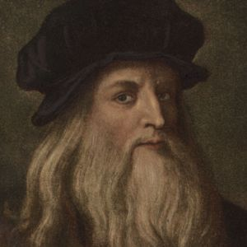
Leonardo di ser Piero da Vinci was an Italian polymath, painter, sculptor, architect, musician, mathematician, engineer, inventor, anatomist, geologist, cartographer, botanist, and writer. He is widely considered to be one of the greatest painters of all time and perhaps the most diversely talented person ever to have lived.
His genius, perhaps more than that of any other figure, epitomized the Renaissance humanist ideal. Leonardo has often been described as the archetype of the Renaissance Man, a man of "unquenchable curiosity" and "feverishly inventive imagination".
According to art historian Helen Gardner, the scope and depth of his interests were without precedent and "his mind and personality seem to us superhuman, the man himself mysterious and remote".
Marco Rosci states that while there is much speculation about Leonardo, his vision of the world is essentially logical rather than mysterious, and that the empirical methods he employed were unusual for his time.

Leonardo was, and is, renowned primarily as a painter. Among his works, the Mona Lisa is the most famous and most parodied portrait and The Last Supper the most reproduced religious painting of all time, with their fame approached only by Michelangelo's The Creation of Adam. Leonardo's drawing of the Vitruvian Man is also regarded as a cultural icon, being reproduced on items as varied as the euro coin, textbooks, and T-shirts. Perhaps fifteen of his paintings have survived, the small number because of his constant, and frequently disastrous, experimentation with new techniques, and his chronic procrastination. Nevertheless, these few works, together with his notebooks, which contain drawings, scientific diagrams, and his thoughts on the nature of painting, compose a contribution to later generations of artists rivaled only by that of his contemporary, Michelangelo.

- Linguistic-Verbal Intelligence

People who are strong in linguistic-verbal intelligence are able to use words well, both when writing and speaking. These individuals are typically very good at writing stories, memorizing information and reading.

Characteristics of Linguistic-Verbal Intelligence

- Good at remembering written and spoken information
- Enjoys reading and writing
- Good at debating or giving persuasive speeches
- Able to explain things well
- Often uses humor when telling stories

Potential Career Choices

- Writer / Journalist
- Lawyer
- Teacher

Real Life Example:
Agatha Christie
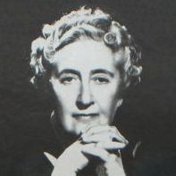

Dame Agatha Mary Clarissa Christie, DBE was an English crime novelist, short story writer, and playwright. She also wrote six romances under the name Mary Westmacott, but she is best known for the 66 detective novels and 14 short story collections she wrote under her own name, most of which revolve around the investigations of such characters as Hercule Poirot, Miss Jane Marple, Mr Satterthwaite, and Tommy and Tuppence. She also wrote the world's longest-running play, The Mousetrap.

The Guinness Book of World Records lists Christie as the best-selling novelist of all time. Her novels have sold roughly 2 billion copies, and her estate claims that her works come third in the rankings of the world's most-widely published books, behind Shakespeare's works and the Bible. According to Index Translationum, Christie is the most-translated individual author – having been translated into at least 103 languages.And Then There Were None is Christie's best-selling novel with 100 million sales to date, making it the world's best-selling mystery ever, and one of the best-selling books of all time. In 1971, she was made a Dame by Queen Elizabeth II at Buckingham Palace. In 2013, The Murder of Roger Ackroyd was voted the best crime novel ever by 600 fellow writers of the Crime Writers' Association.

Christie's stage play The Mousetrap holds the record for the longest initial run: it opened at the Ambassadors Theatre in London on 25 November 1952 and as of 2012 is still running after more than 25,000 performances.In 1955, Christie was the first recipient of the Mystery Writers of America's highest honour, the Grand Master Award, and in the same year Witness for the Prosecution was given an Edgar Award by the MWA for Best Play. Most of her books and short stories have been adapted for television, radio, video games and comics, and more than thirty feature films have been based on her work.

- Logical-Mathematical Intelligence

People who are strong in logical-mathematical intelligence are good at reasoning, recognizing patterns and logically analyze problems. These individuals tend to think conceptually about numbers, relationships, and patterns.

Characteristics of Logical-Mathematical Intelligence

- Excellent problem-solving skills
- Enjoys thinking about abstract ideas
- Likes conducting scientific experiments
- Good and solving complex computations

Potential Career Choices

- Scientist
- Mathematician
- Computer programmer
- Engineer
- Accountant

Real Life Example:
Albert Einstein

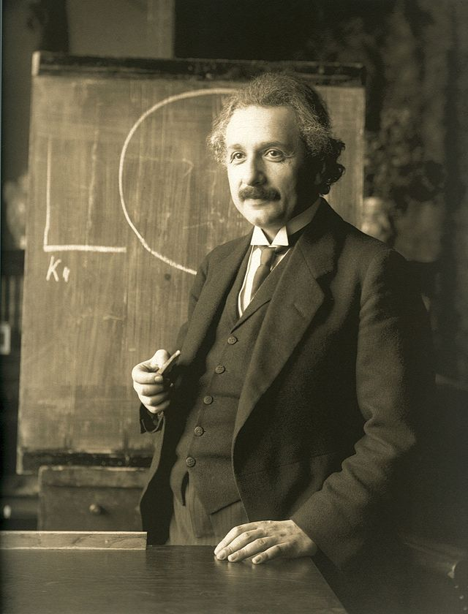

Albert Einstein was a German-born theoretical physicist and philosopher of science.He developed the general theory of relativity, one of the two pillars of modern physics (alongside quantum mechanics). He is best known in popular culture for his mass–energy equivalence formula E = mc2 (which has been dubbed "the world's most famous equation").He received the 1921 Nobel Prize in Physics "for his services to theoretical physics, and especially for his discovery of the law of the photoelectric effect".The latter was pivotal in establishing quantum theory.

Throughout his life, Einstein published hundreds of books and articles. In addition to the work he did by himself he also collaborated with other scientists on additional projects including the Bose–Einstein statistics, the Einstein refrigerator and others.

Near the beginning of his career, Einstein thought that Newtonian mechanics was no longer enough to reconcile the laws of classical mechanics with the laws of the electromagnetic field. This led to the development of his special theory of relativity. He realized, however, that the principle of relativity could also be extended to gravitational fields, and with his subsequent theory of gravitation in 1916, he published a paper on the general theory of relativity. He continued to deal with problems of statistical mechanics and quantum theory, which led to his explanations of particle theory and the motion of molecules. He also investigated the thermal properties of light which laid the foundation of the photon theory of light. In 1917, Einstein applied the general theory of relativity to model the large-scale structure of the universe.

- Bodily-Kinesthetic Intelligence

Those who have high bodily-kinesthetic intelligence are said to be good at body movement, performing actions and physical control. People who are strong in this area tend to have excellent hand-eye coordination and dexterity.

Characteristics of Bodily-Kinesthetic Intelligence

- Good at dancing and sports
- Enjoy creating things with their hands
- Excellent physical coordination
- Tends to remember by doing, rather than hearing or seeing

Potential Career Choices

- Dancer
- Builder
- Sculptor
- Actor

Real Life Example

Auguste Rodin
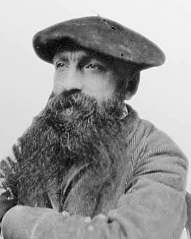

François-Auguste-René Rodin was a French sculptor. Although Rodin is generally considered the progenitor of modern sculpture, he did not set out to rebel against the past. He was schooled traditionally, took a craftsman-like approach to his work, and desired academic recognition, although he was never accepted into Paris's foremost school of art.

Sculpturally, Rodin possessed a unique ability to model a complex, turbulent, deeply pocketed surface in clay. Many of his most notable sculptures were roundly criticized during his lifetime. They clashed with the predominant figure sculpture tradition, in which works were decorative, formulaic, or highly thematic. Rodin's most original work departed from traditional themes of mythology and allegory, modeled the human body with realism, and celebrated individual character and physicality. Rodin was sensitive to the controversy surrounding his work, but refused to change his style. Successive works brought increasing favor from the government and the artistic community.

From the unexpected realism of his first major figure – inspired by his 1875 trip to Italy – to the unconventional memorials whose commissions he later sought, Rodin's reputation grew, such that he became the preeminent French sculptor of his time. By 1900, he was a world-renowned artist. Wealthy private clients sought Rodin's work after his World's Fair exhibit, and he kept company with a variety of high-profile intellectuals and artists. He married his lifelong companion, Rose Beuret, in the last year of both their lives. His sculptures suffered a decline in popularity after his death in 1917, but within a few decades, his legacy solidified. Rodin remains one of the few sculptors widely known outside the visual arts community.

- Musical Intelligence

People who have strong musical intelligence are good and thinking in patterns, rhythms and sounds. They have a strong appreciation for music and are often good at musical composition and performance.

Characteristics of Musical Intelligence

- Enjoy singing and playing musical instruments
- Recognizes musical patterns and tones easily
- Good at remembering songs and melodies
- Rich understanding of musical structure, rhythm and notes

Potential Career Choices

- Musician
- Composer
- Singer
- Music Teacher
- Conductor

Real Life Example:

Sergei Rachmaninoff

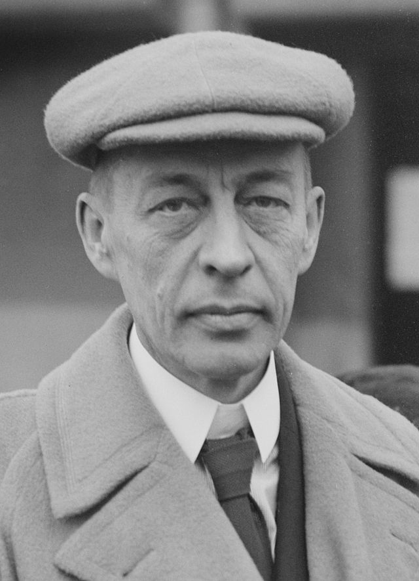

Sergei Rachmaninoff was a Russian composer, pianist, and conductor Rachmaninoff is widely considered one of the finest pianists of his day and, as a composer, one of the last great representatives of Romanticism in Russian classical music.

When in concert as pianist or conductor during the 1920s, 30s, and 40s, his massive presence on stage embodied bygone artistic values and a style of expression missed greatly by the public.

Early influences of Tchaikovsky, Rimsky-Korsakov, and other Russian composers gave way to a personal style notable for its song-like melodicism, expressiveness and his use of rich orchestral colors.The piano is featured prominently in Rachmaninoff's compositional output, and through his own skills as a performer he explored the expressive possibilities of the instrument.

Rachmaninoff was an active composer until March 1897, when his Symphony No. 1 received its disastrous premiere under Alexander Glazunov. The symphony was trashed by critics, including César Cui, although much is owed to the clumsiness of Glazunov's interpretation, his mediocre conducting skills, and suspected drunkenness while on the podium. Symphony No. 1's premiere haunted Rachmaninoff and the composition was not heard again until after his death. The fiasco plunged Rachmaninoff into a depression that left him unable to compose large-scale works for three years. He worked mainly as a concert pianist, conductor, and teacher before undergoing hypnotic treatment with psychologist Nicolai Dahl. Rachmaninoff steadily recovered and began work on his Piano Concerto No. 2 in 1900, arguably the most beloved concerto in western music.

- Interpersonal Intelligence

Those who have strong interpersonal intelligence are good understanding and interacting with other people. These individuals are skilled at assessing the emotions, motivations, desires and intentions of those around them.

Characteristics of Interpersonal Intelligence

- Good at communicating verbally
- Skilled at nonverbal communication
- See situations from different perspectives
- Create positive relationships with others
- Good at resolving conflict in groups

Potential Career Choices

- Psychologist
- Philosopher
- Counselor
- Sales person
- Politician

Real Life Example:
Martin Luther King, Jr
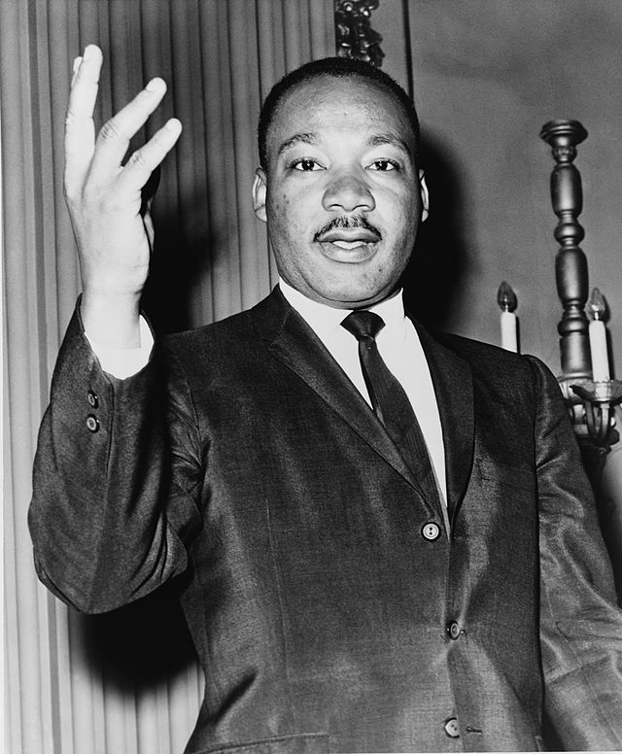

Martin Luther King, Jr. (January 15, 1929 – April 4, 1968) was an American pastor, activist, humanitarian, and leader in the African-American Civil Rights Movement. He is best known for his role in the advancement of civil rights using nonviolent civil disobedience based on his Christian beliefs.

He was born Michael King, but his father changed his name in honor of the German reformer Martin Luther. A Baptist minister, King became a civil rights activist early in his career. He led the 1955 Montgomery Bus Boycott and helped found the Southern Christian Leadership Conference (SCLC) in 1957, serving as its first president. With the SCLC, King led an unsuccessful struggle against segregation in Albany, Georgia, in 1962, and organized nonviolent protests in Birmingham, Alabama, that attracted national attention following television news coverage of the brutal police response. King also helped to organize the 1963 March on Washington, where he delivered his famous "I Have a Dream" speech. There, he established his reputation as one of the greatest orators in American history.

On October 14, 1964, King received the Nobel Peace Prize for combating racial inequality through nonviolence. In 1965, he and the SCLC helped to organize the Selma to Montgomery marches and the following year, he took the movement north to Chicago to work on segregated housing. In the final years of his life, King expanded his focus to include poverty and speak against the Vietnam War, alienating many of his liberal allies with a 1967 speech titled "Beyond Vietnam".

- Intrapersonal Intelligence

Individuals who are strong in intrapersonal intelligence are good at being aware of their own emotional states, feelings and motivations. They tend to enjoy self-reflection and analysis, including day-dreaming, exploring relationships with others and assessing their personal strengths.

Characteristics of Intrapersonal Intelligence

- Good at analyzing their strengths and weaknesses
- Enjoys analyzing theories and ideas
- Excellent self-awareness
- Clearly understands the basis for their own motivations and feelings

Potential Career Choices

- Philosopher
- Writer
- Theorist
- Scientist

Real Life Example:

Aristotle
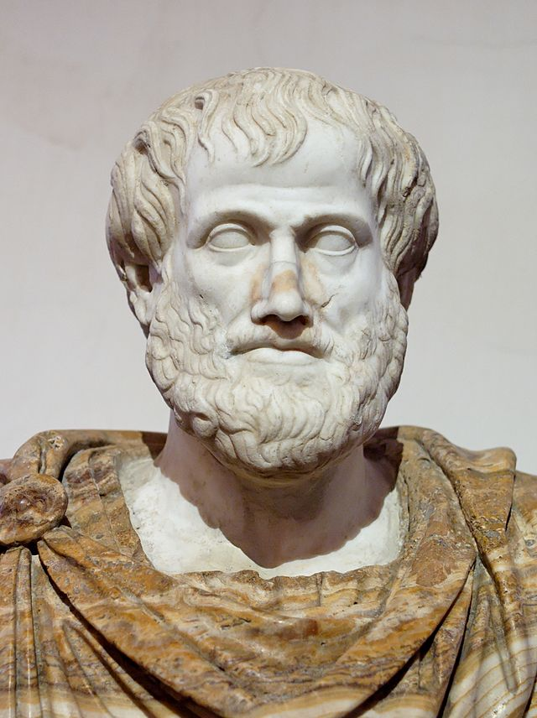

Aristotle was a Greek philosopher and scientist born in the Macedonian city of Stagirus, in 384 BCE. His father, Nicomachus, died when Aristotle was a child, whereafter Proxenus of Atarneus became his guardian. At eighteen, he joined Plato's Academy in Athens and remained there until the age of thirty-seven (c. 347 BCE). His writings cover many subjects – including physics, biology, zoology, metaphysics, logic, ethics, aesthetics, poetry, theater, music, rhetoric, linguistics, politics and government – and constitute the first comprehensive system of Western philosophy. Shortly after Plato died, Aristotle left Athens and, at the request of Philip of Macedon, tutored Alexander the Great between 356 and 323 BCE. According to the Encyclopædia Britannica, "Aristotle was the first genuine scientist in history ... [and] every scientist is in his debt."

Teaching Alexander the Great gave Aristotle many opportunities and an abundance of supplies. He established a library in the Lyceum which aided in the production of many of his hundreds of books. The fact that Aristotle was a pupil of Plato contributed to his former views of Platonism, but, following Plato's death, Aristotle immersed himself in empirical studies and at least in the natural sciences, shifted from Platonism towards a more empiricist position.Although in some places he says knowledge of nature is grounded upon an immaterial intellect, he also insisted that this nous only fully develops in a human because of experience and perception. Aristotle's views on natural sciences represent the groundwork underlying many of his works.

Aristotle's views on physical science profoundly shaped medieval scholarship. Their influence extended into the Renaissance and were not replaced systematically until the Enlightenment and theories such as classical mechanics. Some of Aristotle's zoological observations, such as on the hectocotyl (reproductive) arm of the octopus, were not confirmed or refuted until the 19th century. His works contain the earliest known formal study of logic, which was incorporated in the late 19th century into modern formal logic.

In metaphysics, Aristotelianism profoundly influenced Judeo-Islamic philosophical and theological thought during the Middle Ages and continues to influence Christian theology, especially the scholastic tradition of the Catholic Church. Aristotle was well known among medieval Muslim intellectuals and revered as "The First Teacher" (Arabic: المعلم الأول‎).

- Naturalistic Intelligence

Naturalistic is the most recent addition to Gardner’s theory and has been met with more resistance than his original seven intelligences. According to Gardner, individuals who are high in this type of intelligence are more in tune with nature and are often interested in nurturing, exploring the environment and learning about other species. These individuals are said to be highly aware of even subtle changes to their environments.

Characteristics of Naturalistic Intelligence

- Interested in subjects such as botany, biology and zoology
- Good at categorizing and cataloging information easily
- May enjoy camping, gardening, hiking and exploring the outdoors
- Doesn’t enjoy learning unfamiliar topics that have no connection to nature

Potential Career Choices

- Biologist
- Conservationist
- Gardener
- Farmer

Real Life Example:
Ansel Adams
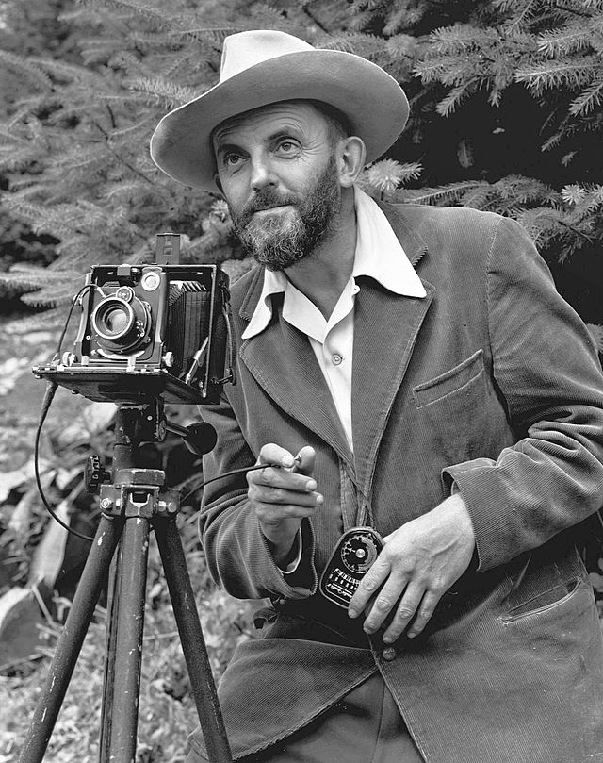

Ansel Easton Adams (February 20, 1902 – April 22, 1984) was an American photographer and environmentalist. His black-and-white landscape photographs of the American West, especially Yosemite National Park, have been widely reproduced on calendars, posters, and books.

With Fred Archer, Adams developed the Zone System as a way to determine proper exposure and adjust the contrast of the final print. The resulting clarity and depth characterized his photographs. Adams primarily used large-format cameras because their high resolution helped ensure sharpness in his images.

Adams founded the photography Group f/64 along with fellow photographers Willard Van Dyke and Edward Weston.

